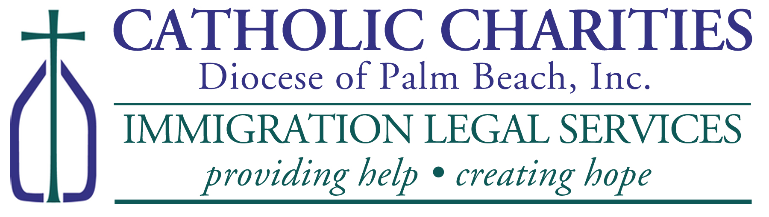
TPS INITIAL REGISTRATION ASSISTANCE FOR HAITIANs!

WHERE: By Appointment Only
Catholic Charities, St. Francis Center
100 W. 20TH Street, Riviera Beach, FL 33404
Please Call (561) 345-2003 for Appointment

PLEASE BRING TO YOUR APPOINTMENT:
- Money Orders (if requesting work authorization card):
  - $545 (Applicants Ages 14-65)
  - $50 (Applicants under age 14)
  - $135 (Applicants ages 66 and over)
- Two (2) Passport Style Photos;
- Copy of Haitian Passport;
- Copy of Visa/I-94 (if Applicable);
- Copy of Haitian Birth Certificate with English Translation;
- Copy Of Prior TPS Approval Notice (if applicable);
- Copy Of Current Employment Authorization Card Front and Back
- Police Clearance Letter From County Sheriff Where You Reside;
- Certified court records for any and all violations of law;
- Proof of continuous Residence in USA since on or before November 6, 2022;
- $310 for Catholic Charities (includes $10 for postage);
- $30/page for any translation necessary.

Deadline to register is August 3, 2024!

