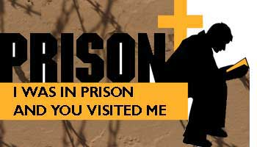 |  |  |  | I Was In Prison  The Online presence for  I Was in Prison Outreach Ministry  Tallahassee, Florida USA  www.iwasinprison.org  (currently under redesign)

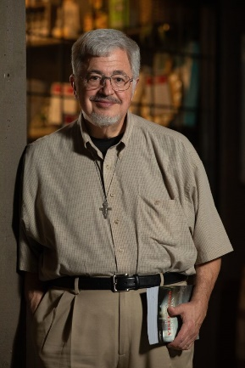
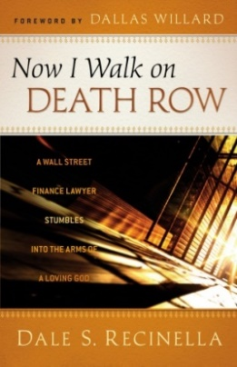

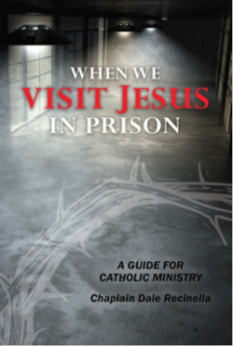
Dale S. Recinella, JD, MTS An Integration of Scripture, Law, History,
Catholic Correctional Chaplain Statistics, and Theology Establishing That
Florida Death Row We Cannot Use the Bible to Support
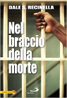
The American Death Penalty

Now I Walk on Death Row: A Wall Street Finance Lawyer Stumbles into the Arms of a Loving God (Chosen Books, April 2011), a personal sharing of his journey to death row and experiences of death row ministry (available through Amazon).
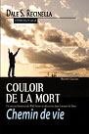
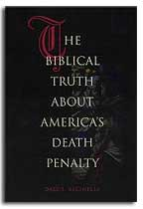
Also available: In Italian: Nel braccio della morte (San Paolo Edizioni: Milan, 2012).
And in French: Couloir de le Mort, Chemin de vie - Un avocat financier de Wall Street se découvre dans l'amour de Dieu (Editions Bénédictines: Saint Benoit-du-Sault, France, 2013).

Dale’s newest book is now available:
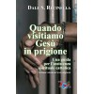
When We Visit Jesus in Prison:
A Guide for Catholic Ministry
2017 Award for Excellence in Publishing – Association
of Catholic Publishers - 1st Place “Resources for Ministry”

NOW available in Italian through EDI (Editrice Domenicana Italiana)
http://edi.na.it/home/650-quando-visitiamo-gesu-in-prigione-una-guida-per-lassistenza-spirituale-cattolica-9788894876468.html

Dale S. Recinella, J.D., M.T.S.
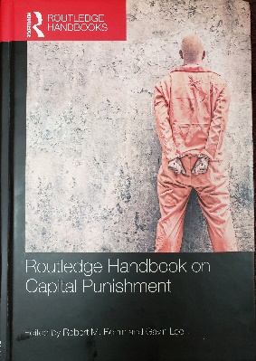

Dale S. Recinella, author of the books listed above and co-author of “Retribution and Capital Punishment: ‘It’s in the Bible, Isn’t It?’”, ch. 8, Routledge Handbook on Capital Punishment (Routledge: NY, 2018), has served since 1990 as a spiritual counselor and Catholic Correctional Chaplain in Florida’s prisons. On behalf of the Catholic Bishops of Florida, in 1998 he began ministering cell-to-cell to the ≈ 400 men on Florida’s death row and the ≈ 2,000 men in Florida’s long-term solitary confinement.

For 22 years, he and his wife, Dr. Susan Recinella, have ministered as a team during executions: he serving as spiritual advisor to the condemned and his wife serving as a lay minister to the condemned’s family and loved ones. They also minister to the families and loved ones of murder victims in non-capital cases.

Mr. Recinella, who received a Masters in Theological Studies (M.T.S.) summa cum laude from Ave Maria University’s Institute for Pastoral Theology (2009) and law degree magna cum laude from Notre Dame University Law School (1976), is a licensed Florida lawyer and has taught international law/business ethics in Europe, at the undergraduate and graduate levels, at St. John’s University at the Vatican (Oratorio) and at Temple University in Rome; and has designed and taught Credible and Responsible Ministry in Prison, Certificate Program in Prison and Detention Ministry, at Saint Leo University Theology Department, Saint Leo, Florida USA (2013 - 2015).

He has been a Community of Faith columnist for The Tallahassee Democrat and for over ten years was the prolife/prison and death penalty columnist for the statewide Florida Catholic; and he has received:

- Pro Ecclesia et Pontifice, issued by Pope Francis, Florida Bishops (2016).
- Dove Award for Extraordinary Service to the Tallahassee Community, Good News Outreach (2017).
- Law & Spirituality Award, Catholic Lawyers Guild, St. Augustine Diocese (2011).
- Humanitarian Award, Franciscan Alumni Association (2001).
- Catholic Press Award, Catholic Press Association (2000).
- University of Notre Dame Exemplar, faith and citizenship in action (1997).
- Citizen Volunteer of the Year, by the Executive Staff of Florida State Prison (2013) and the chaplains of Union Correctional Institution (2000).

Has appeared frequently on worldwide Vatican Radio, extensively addresses audiences nationally and in Europe, and with Dr. Susan, has raised 5 children and has 13 grandchildren.

Email: BrotherDale@comcast.net I Was in Prison Outreach Ministry
Office (Mon & Fri) 850.205.6818 201 West Park Avenue, Suite 301
Cell (when not in prison): 904.881.7747 Tallahassee, FL 32301-7760 USA

