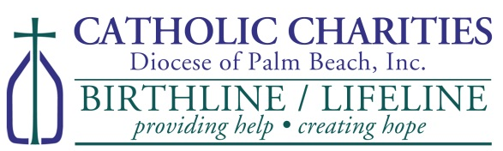
Life!
for
Steps

**********************************************************************
LOCAL LEADER’S GUIDE
to promoting and supporting Steps for Life!

The Purpose – Steps for Life! is a fundraiser to: 1) raise $$ for Birthline/Lifeline; 2) raise awareness of the pro-life cause and Birthline/Lifeline services; and 3) pray together for a Culture of Life.
How it Works – Throughout the month of October, individuals and groups collect $$ and make a pledge to pray for the pro-life cause. Commitments can be mailed to, dropped off at, or called in to Birthline/Lifeline. See brochure/pledge card for complete details.
PRIZES!! $$ will be awarded to the top individual collector and the top group collector. This year we will also be awarding the school that collects the most $$ and logs the most rosaries prayed!

What can you do to help?
As a leader at a local church or school, we need your help to promote this PRO-LIFE fundraiser. Here are some ideas or you can create your own!
- Hold a school-wide fundraiser, such as a $2 dress down day or other event, to encourage students to contribute.
- Post a link to www.ccdpb.org on your parish’s or school’s social media. Tag others who may be interested. This year, anyone can participate from anywhere!
- Place an advertisement in your parish bulletin promoting this fundraiser.
- Contact groups at your church or school—confirmation and faith formation classes, youth groups, ministries, scout troops, CCW, Knights of Columbus, and Columbiette Councils—and encourage them to participate.
- Hold a small group event to pray and collect donations.
- Request a Mass intention and speak with your pastor for permission to solicit donations after Mass from parishioners who want to contribute. Donation boxes and flyers can be obtained by contacting Birthline/Lifeline.
- With your pastor’s/principal’s approval, organize a friendly competition within your parish/school among individuals (ex. priests and deacons, well-known parishioners, or teachers) or groups (ex. classes, grade levels, ministries, or clubs) to see who can raise the most $$ for Birthline/Lifeline. The “winner” can claim bragging rights until next year!
- Most importantly, please pray that Steps for Life! is a success!

Questions? Need more brochures/pledge cards?
Visit www.ccdpb.org and click on “Steps for Life” banner
or call Birthline/Lifeline at 561-732-0570.

