**CULTURE OF LIFE CONFERENCE**

**October 24, 2020**

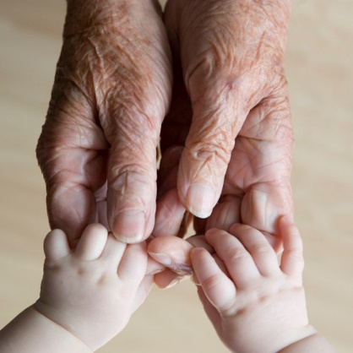

**REGISTRATION FORM:**

(Please Print)

**NAME**: **________________________________________________________________**

**ADDRESS: ______________________________________________________________**

**CITY: __________________________________________________________________**

**STATE: _____ ZIP: _______________________________________________________**

**PHONE#: (____)_________________________________________________________**

**EMAIL: ________________________________________________________________**

**□ **Respect Life  **□ **Knights of Columbus **□ **Catholic Council of Women

**Other Organization: _____________________________________________________**

**DIOCESE:______________________________________________________________**

**PARISH: _______________________________________________________________**

**CONFERENCE–** Register Online at [www.ccdpb.org/respectlife2020](http://www.ccdpb.org/respectlife2020)

Make check or suggested donation for 25.00 payable to:

Catholic Charities RLC 2020

9995 N. Military Trail

Palm Beach Gardens, FL 33410

Credit Card ____________________________________________ EXP:_____________

CVV:___________

Please mail check/credit card information along with registration.

The link to the online conference will be sent prior to the event.